Office Oauth Account Config Steps
Overview:
This document comprises steps to setup an Azure app, which provides following parameters to configure provider to send mail via OFFICE OAUTH.
- ClientId - can be obtained in step 6
- TenantId - can be obtained in step 6
- ClientSecret (ClientSecret value) - can be obtained in step 9
- id (ClientSecret id) - can be obtained in step 9

Steps to create Azure App:
Step1: Go to below url:
https://portal.azure.com/#home
Step2: Click “Azure Active Directory” Icon

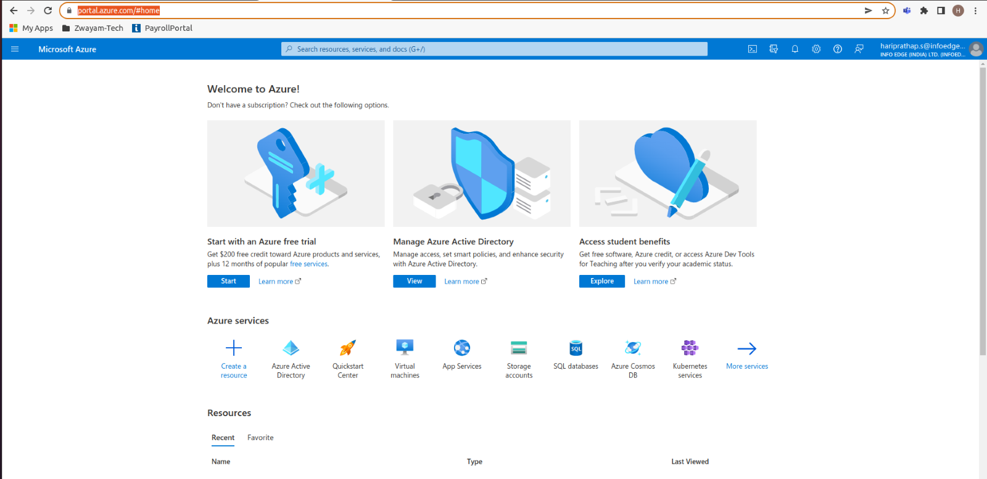
Step3: Click “App registrations” in left side pane
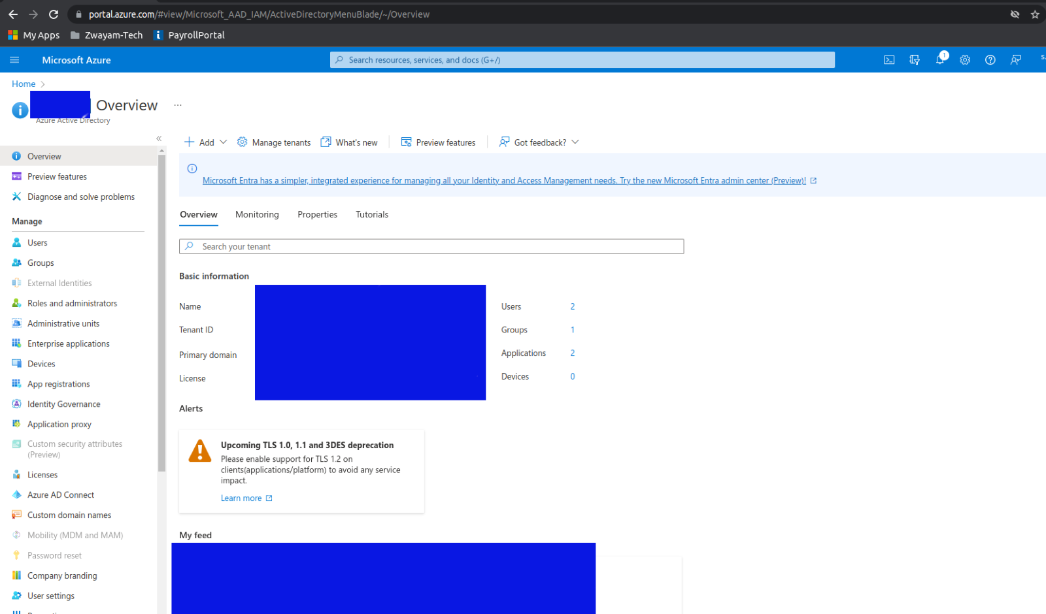

Step4: Click “New registration”
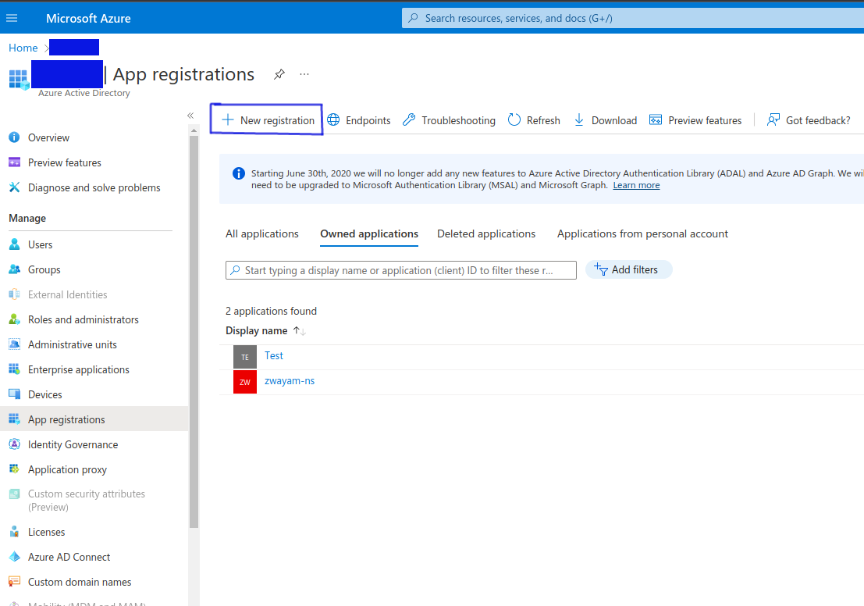

Step5: Enter a name for the app and select “Accounts in this organizational directory only” option under supported account types and then click “Register” button
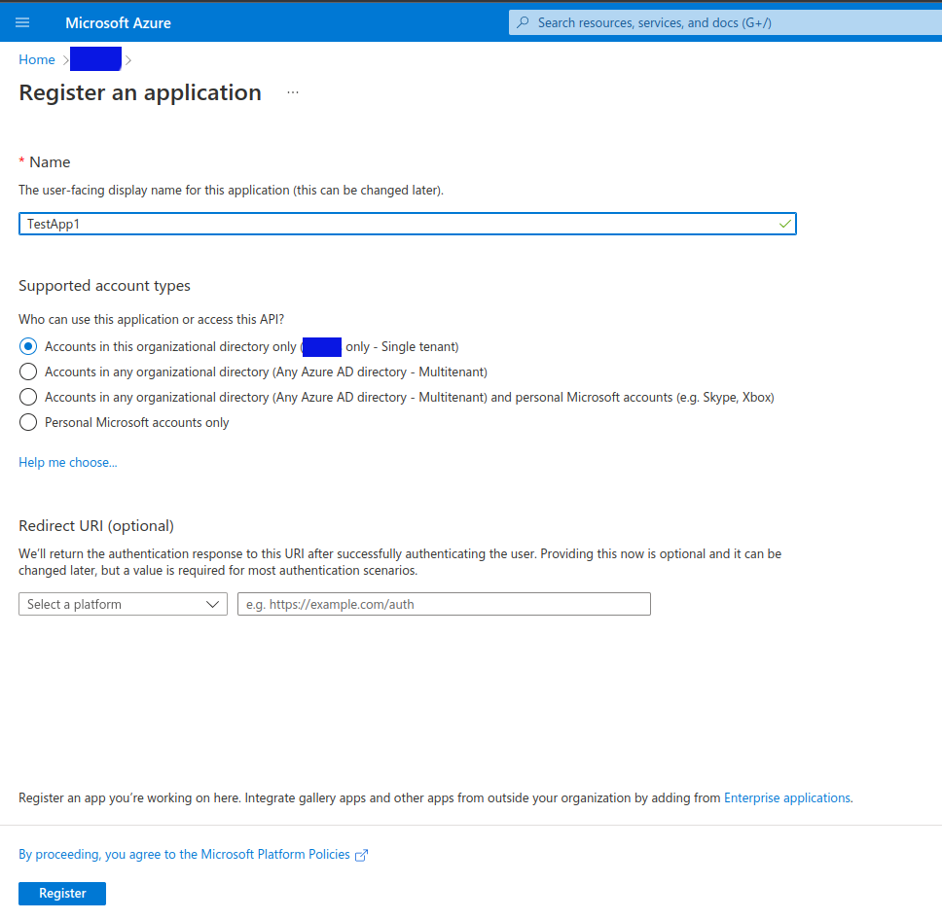

Steps to Create Client secret:
Step6: Once registered, client Id and tenant Id can be obtained from the app dashboard screen(will redirect after clicked register button in the previous step). Click “Add a certificate or secret” hyper link text in “Client credentials” key
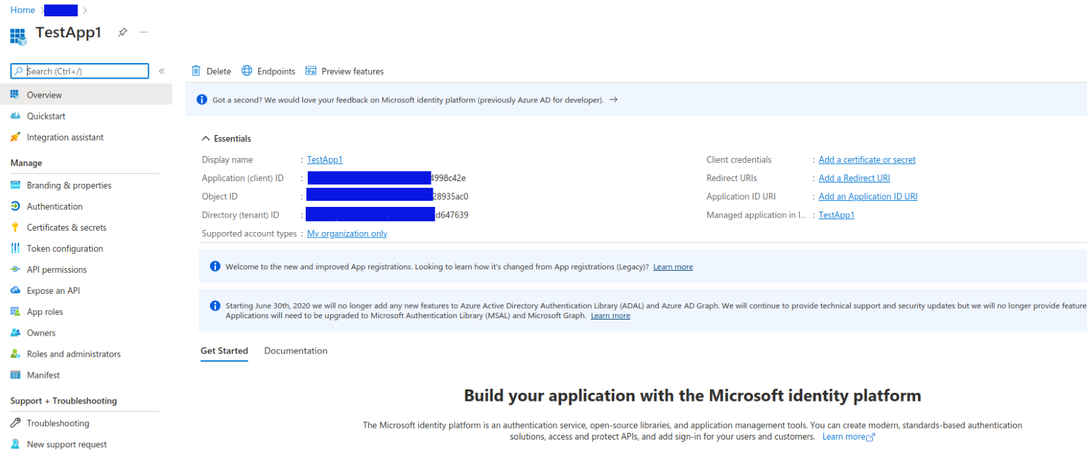

Step7: Click “New Client secret”
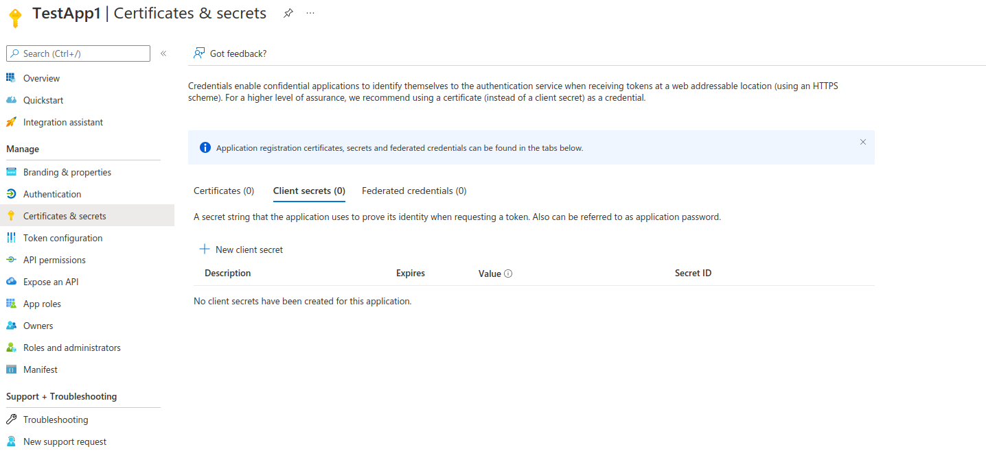

Step8: Enter description and set expiry and then click Add
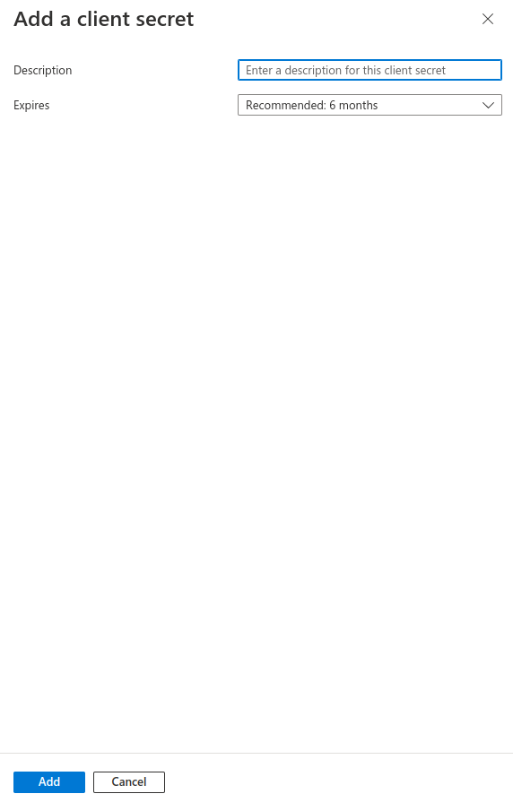

Step9: Client secret Id and value can be obtained in this screen.

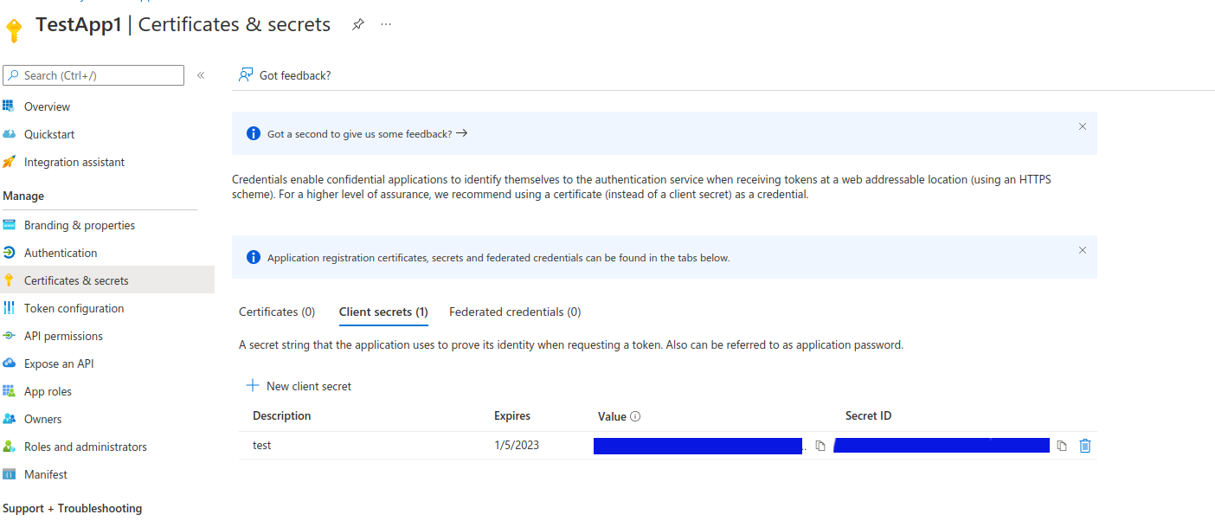
Steps to Add permission to the app:
Step10: To set the permission, click “API permissions” in the left pane. Then Click “Add a permission”
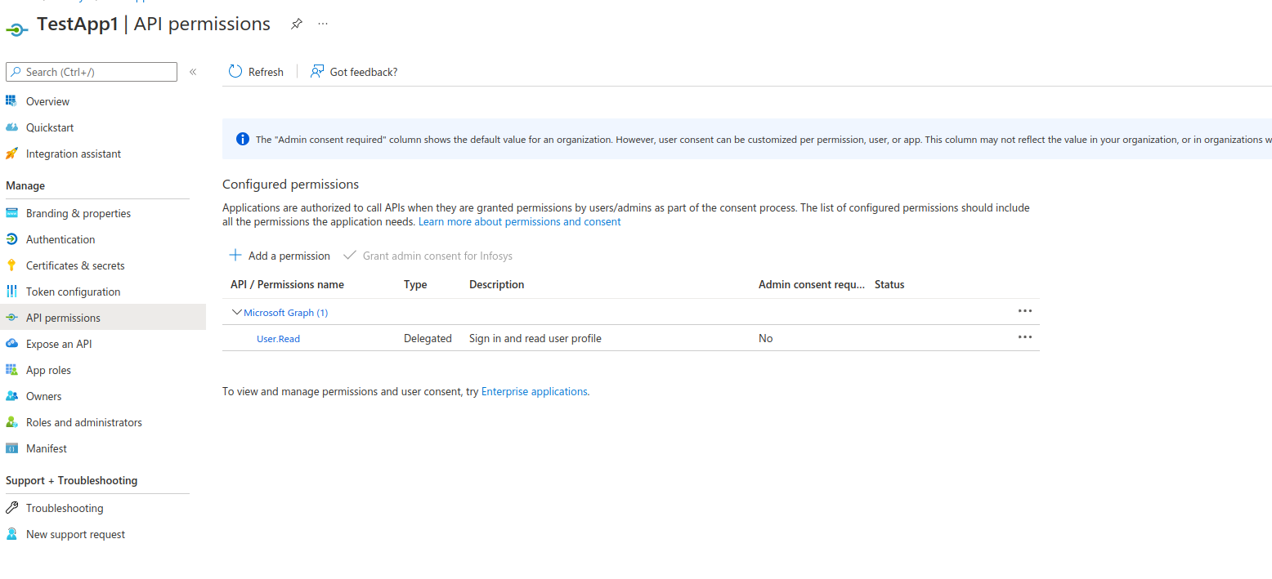
Step11: Select Microsoft Graph
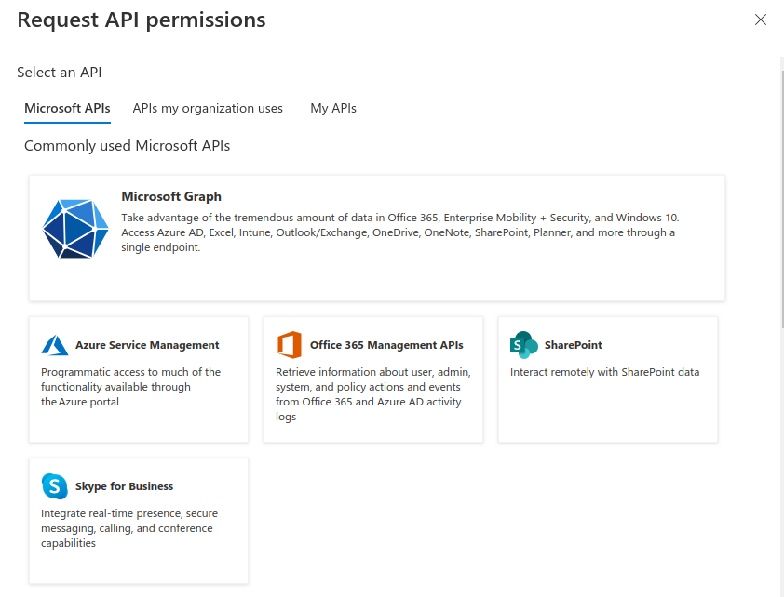
Step12: Select Application permissions
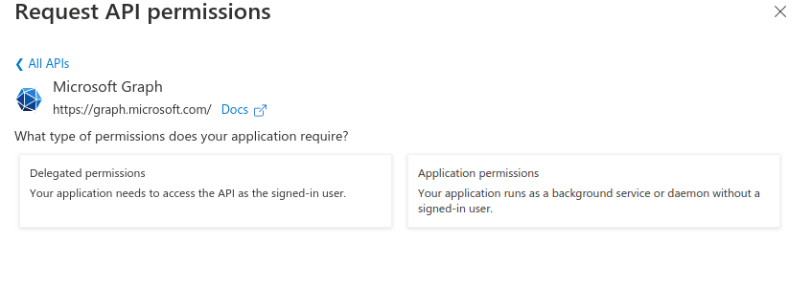
Step13: Search for Mail and select “Mail.Send” then click “Add permissions”
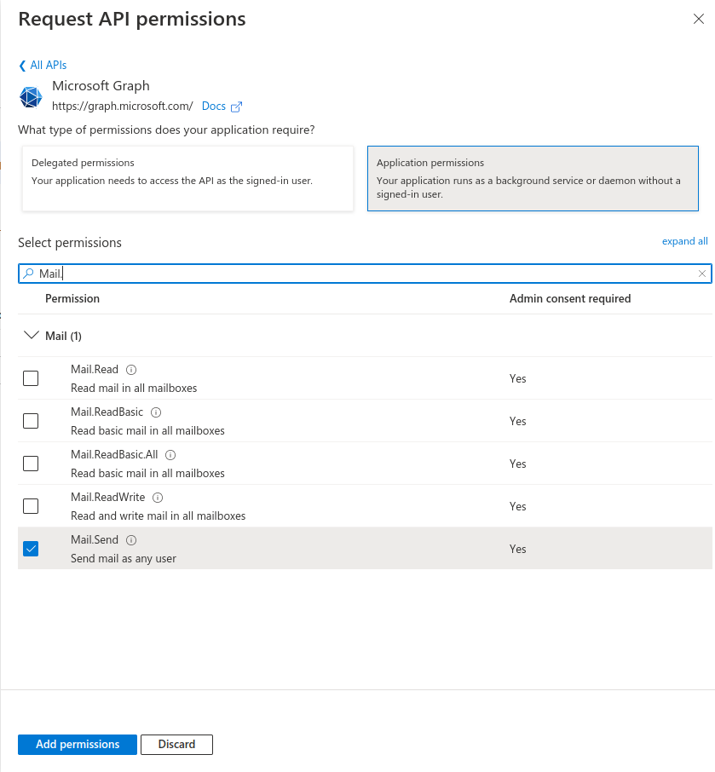
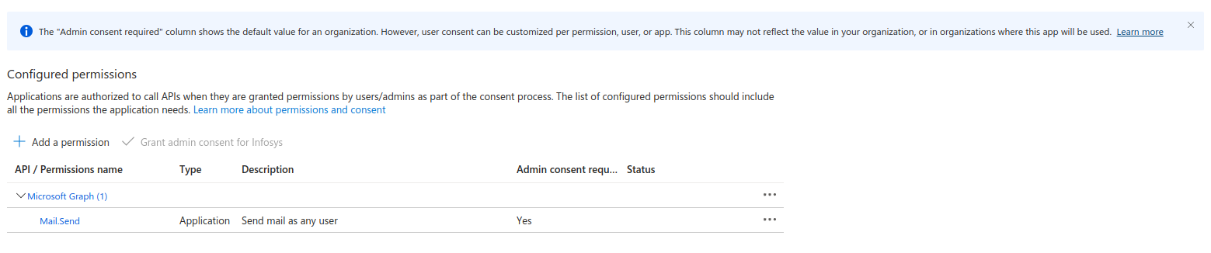
Step14: Once the permission added, Admin consent needs to be given for the same. Click “Grant admin consent for Default directory” on top of the permission list

Step15: Click “yes” in the Grant admin consent confirmation
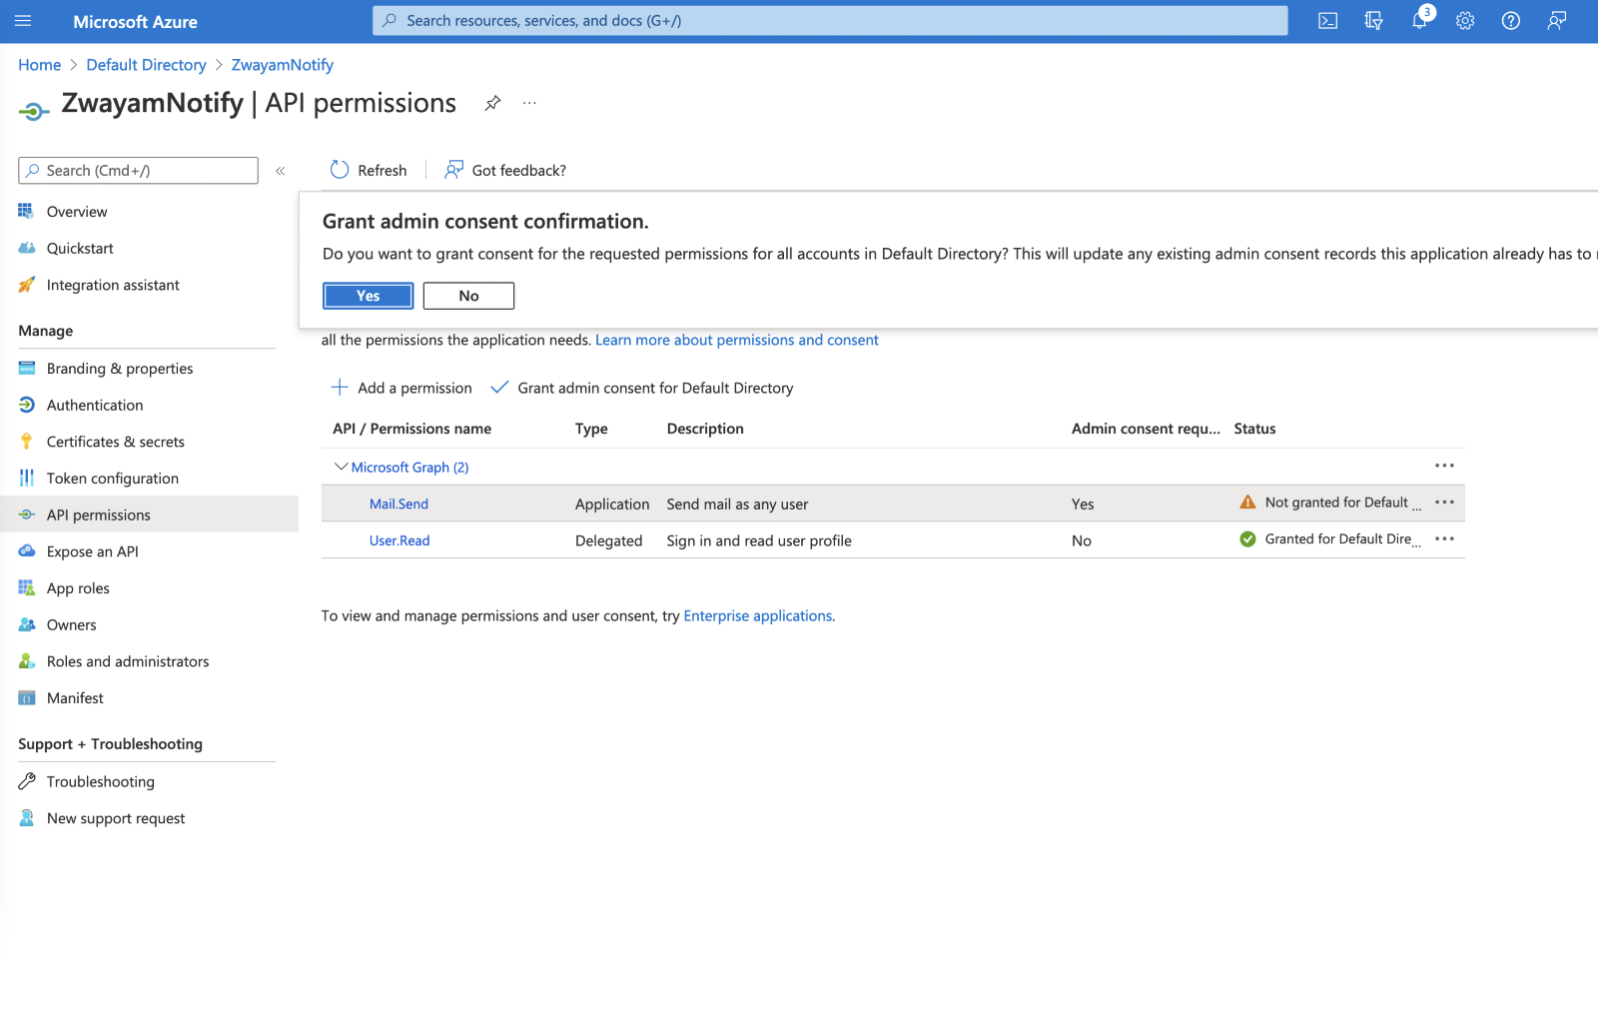
Step16: Please ensure the status of the permission is green.
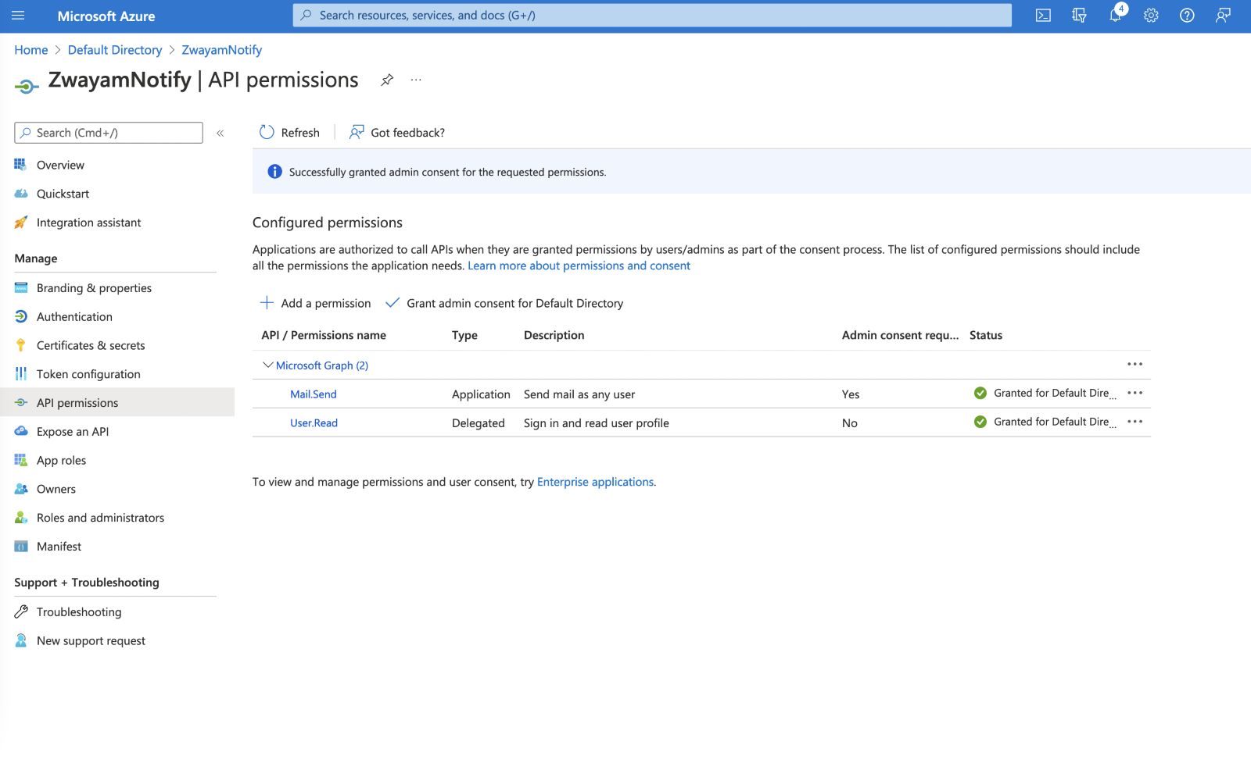
Step17: Likewise add below permissions
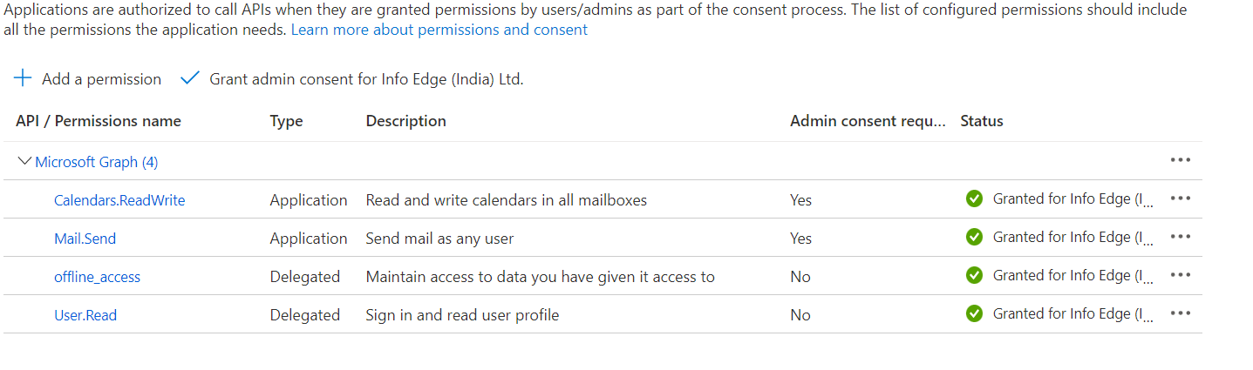
Azure app setup is successfully completed

